Cross infection

As well as providing our patients in Sheffield with the highest standards of care we also provide a safe and clean environment for our staff and patients. Disposable items are used whenever is possible and our cross infection is housed in our purpose built central sterilization unit.
The vacuum autoclave lies at the hearth, of the sterilization process. Backed up by a dedicated hand piece sterilize and washer disinfector.
Reverse osmosis water is used for all the cross infection machinery and in the surgery.
Sterilox is used in the surgery and the water lines to maintain an infection free environment.

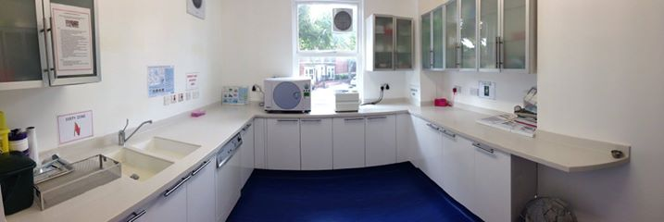

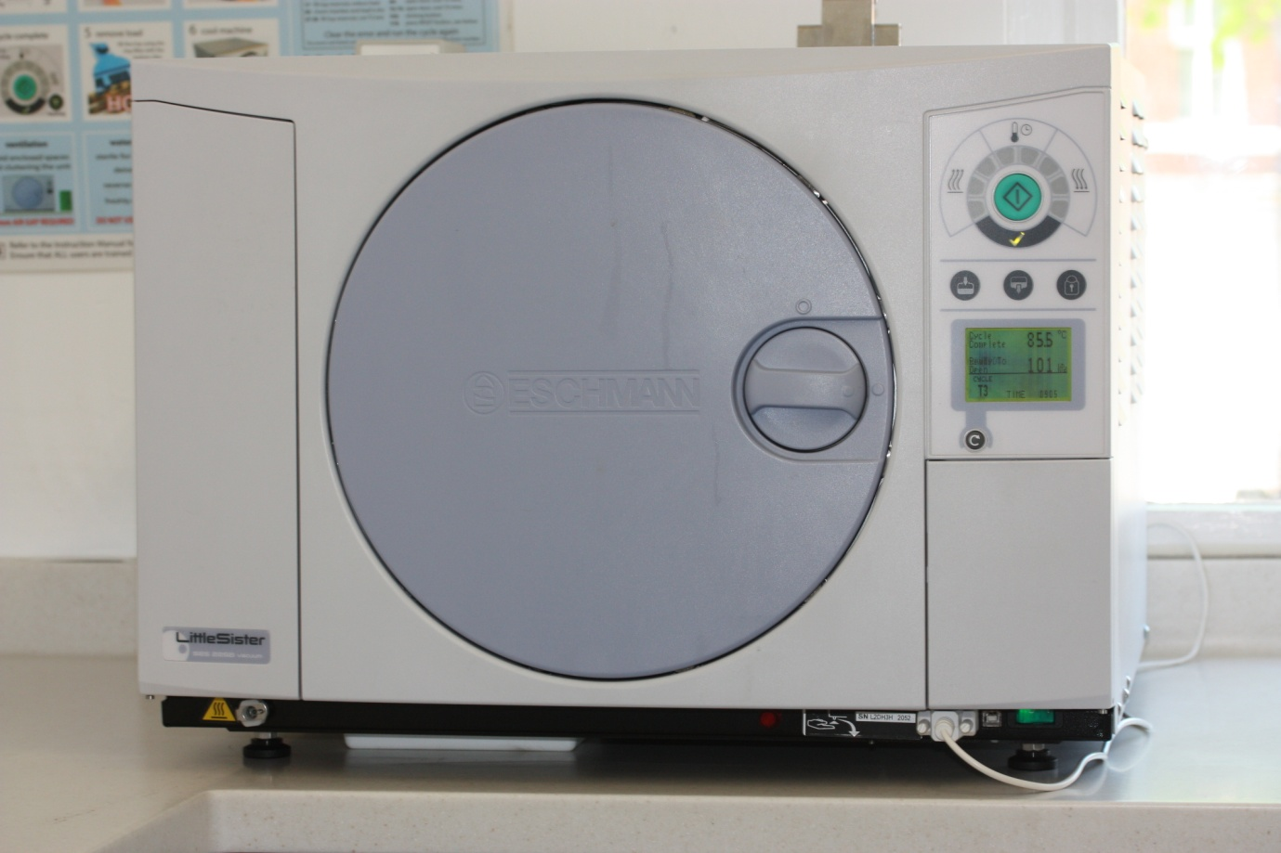

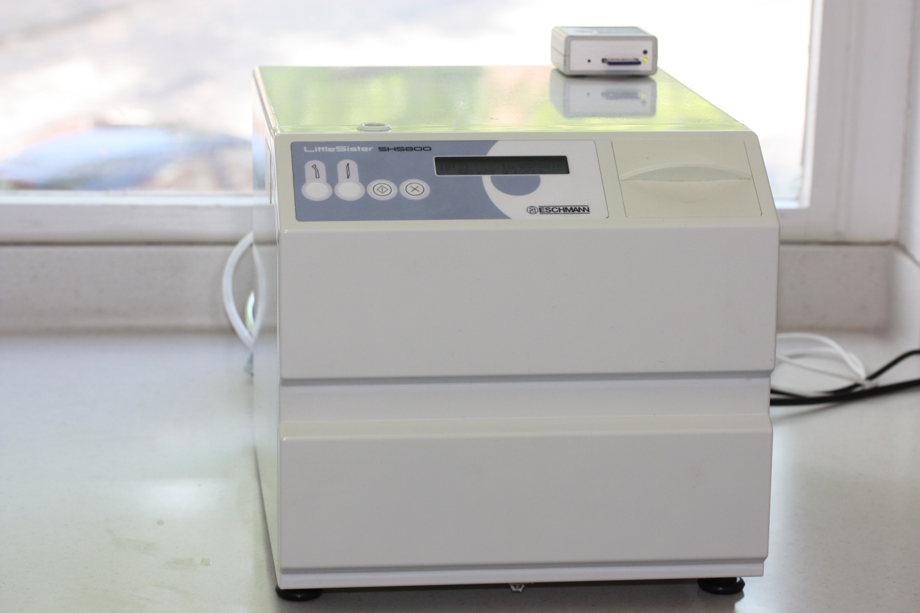

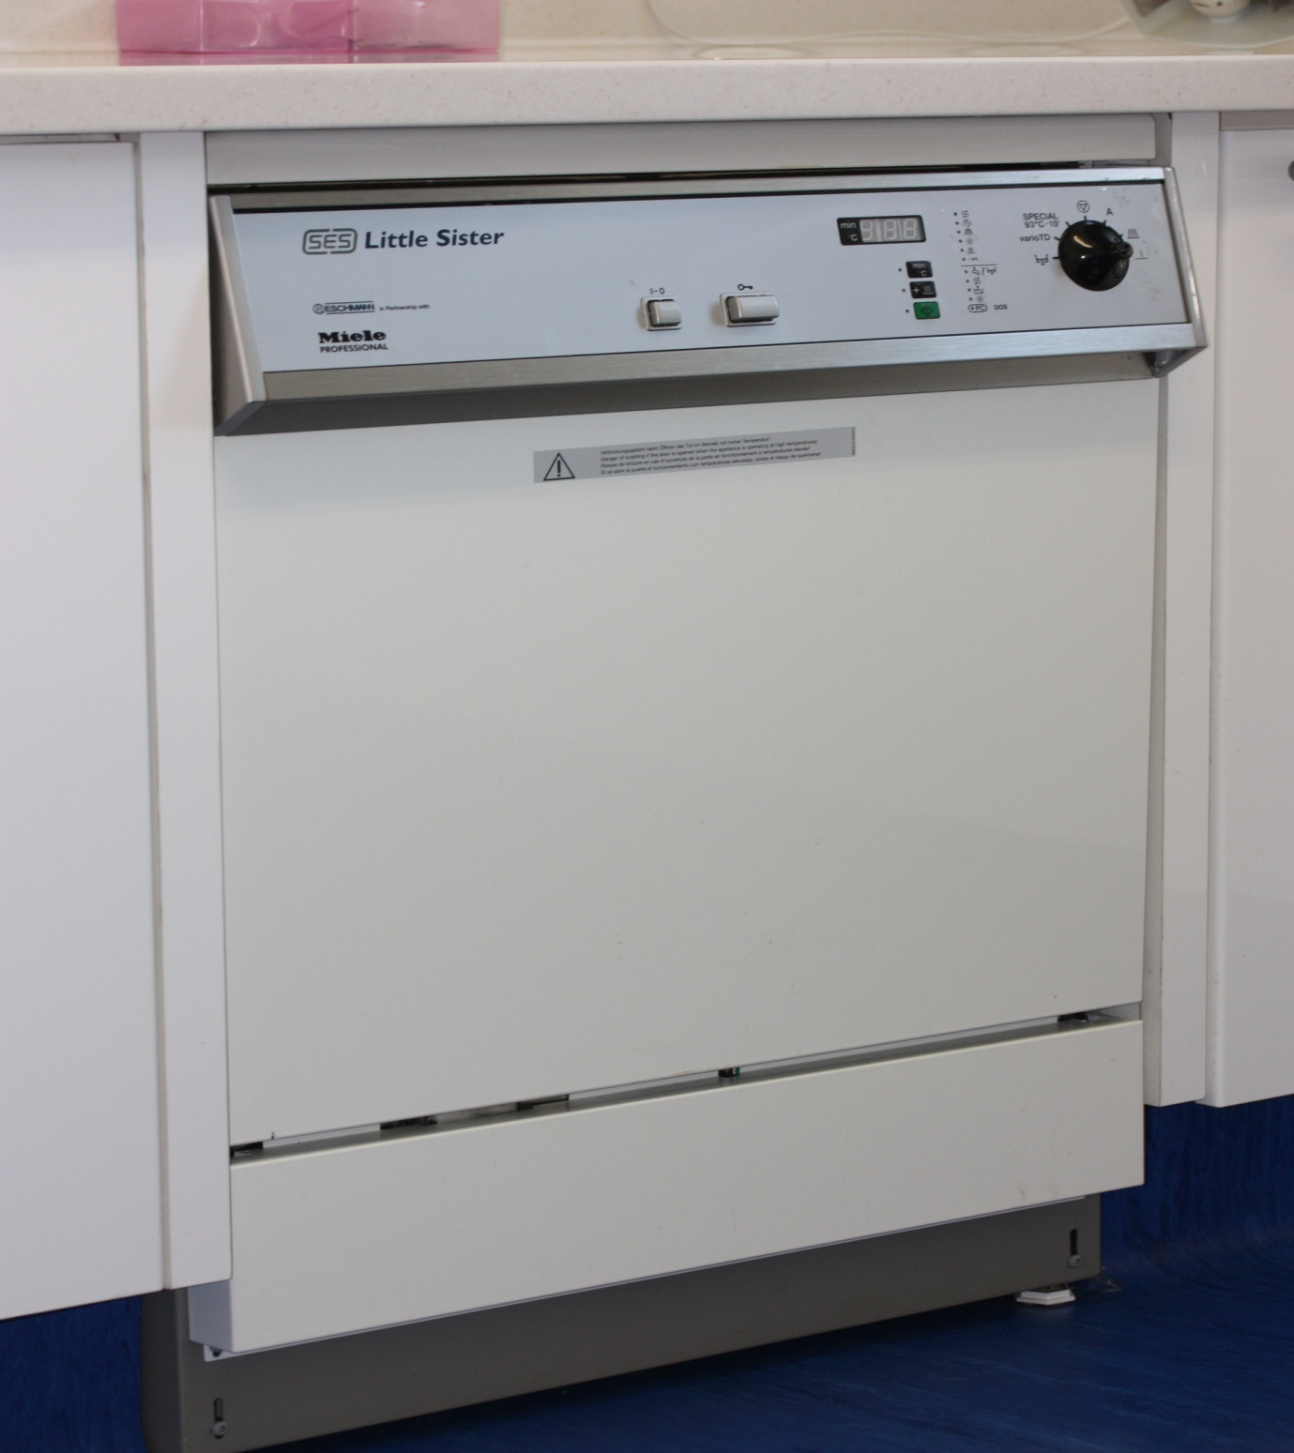
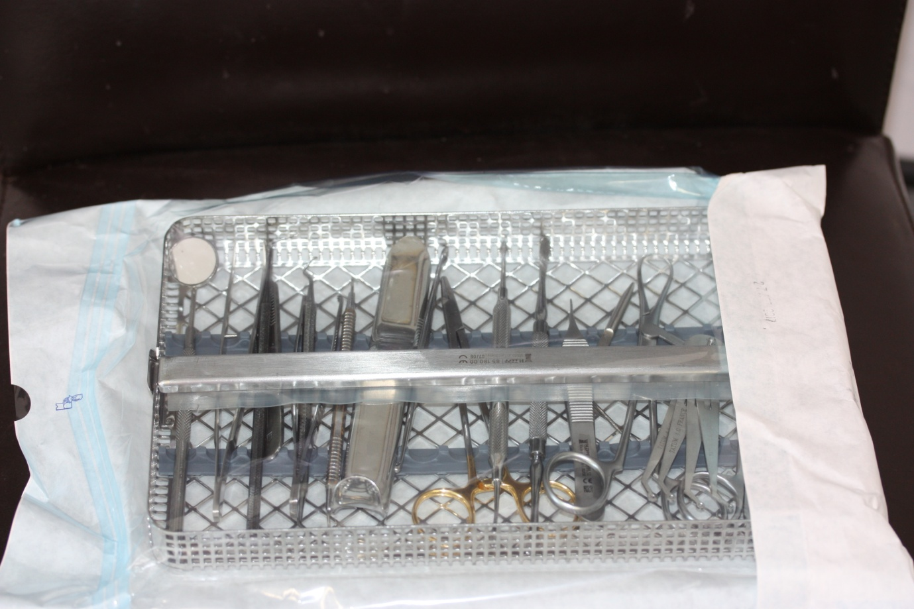

We follow the guidance set by the Department of Health regarding cross infection control in dental practice. This is the HTM105

